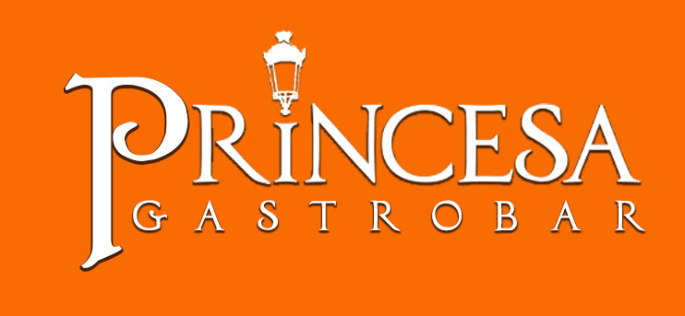

Puerta de San Juan

Appetizers
Choose Three Options

Fried Chicken Cracklings
Pork or Chicken Bites in Mushroom Sauce
International Cheese Platter
Tropical Grouper Ceviche Shots (3 oz.)
Mediterranean Cold Cuts
Beef Cones
Chicken Cones
Spicy Crab Cones
Fresh Fruit Platter
Spanish Sausage in Red Wine
Meatballs Marinara
“Batey Criollo” (A Combination of Corn Fritters, Guava Turnover, Mini Alcapurria, Mini Chicken Turnover)
Puerto Rican Sausage Arancinis

Soups & Salads
(Choose one Option)

Pumpkin Cream Soup
Potato & Bacon Cream Soup
Plantain Soup
Roots & Vegetables Soup
Yautia Cream Soup
Pigeon Peas Soup
Caesar Salad
Mixed Greens Salad with Balsamic Vinaigrette
Nuestra Cultura (Puerto Rican Salad with Sour Sop Vinaigrette)

Main Dishes
(Choose two options to be served as a Duo)

Grilled Skirt Steak with Mango Chimichurri
Pork Medallions wrapped with Bacon in Tamarind Sauce
Chicken Breast Envoltini Stuffed with cassava “Mofongo” in Guava Sauce
Turkey Medallions with Pesto Cream Sauce
Grilled Chicken Breast in Mushroom Veloute
Grouper Filet in Barcelona Sauce
Red Snapper Filet in Passion Fruit Sauce

Sides
(Choose One)

Princesa’s Rice
(Onion, Tri-Color Peppers, Ham, Bacon, Sweet Plantain)
Onion Rice
Vegetable Rice
Sautéed Red Bliss Potatoes
Tuber Mash

All dishes are served with Sautéed Vegetables

Desserts

(Choose One)

Chocolate Mousse

Oreo Cheesecake

Three Milks Cake

Cheese, Coconut or Vanilla Caramel Custard

Services
Bartender, Servers
Basic Set up: Tables, Chairs, cloth napkins,
Cleaning Personnel and Stage Area
(Include Rums of Puerto Rico Presentation)

Unlimited Beverages

Sodas, Virgin Piña Coladas, Water

Price per person: $54.95

Alcoholic Beverages

Option # 1
“Open Bar for 4 hours, with Rums of Puerto Rico”
Don Q Cristal, Don Q Flavors, Don Q Añejo, Barrilito Dos Estrellas, Bacardi,
Bacardi Flavors, Trigo Reserva Añejo, Caray, Palo Viejo Cañita, PitoRico, Pitorro,
Club Caribe, Medalla.
$24.95 p/p

Option # 2

Includes Option 1+
“Open Bar” for 4 hours: Coors Light,
Dewar’s White Label, Tito’s Vodka, Beefeater, Felipe II,
Wines: Red and White
$34.95 p/p

Option # 3 (Premium Spirits)

Incluye opción 1+
“Open Bar” por 4 horas: Michellob, Medalla,
Bacardi 8, Caliche Rum, Dewar’s 12, Woodford Reserve,
Tito’s Vodka, Ketel One, Bombay Sapphire, Hennessy VS,
Wines: Red, White and Sparkling.
$38.95 p/p

Option # 4
(By the Bottle - 750ml.)
Don Q Cristal $40.00 Don Q Limon $45.00
Bacardi $40.00 Bacardi Limon $45.00, Ron Caliche $80.00
Dewar’s White Label $70.00, Cutty Sark $65.00 Black Label $95.00
Finlandia $50.00, Absolut $55.00
Tito’s Vodka $75.00, Grey Goose $95.00
Beefeater $60.00, Patrón Silver $95.00

Option # 5
Corkage: The price to be charged for the corkage of every bottle of liquor brought,
is half the sale price in option # 4, includes the mixtures.
Wine Corkage $15.00 c/u
Bottle Beer by the Case:
Michelob $80.00, Medalla, $70.00, Coors, $80.00,
Heineken y Heineken Light $90.00

*Wines, Sangría Jar or Sparkling Wines starting $25.00 the bottle.

* Acqua Panna 1L (Bottled Still Water) or San Pellegrino 1L(Bottled Sparkling Water), $5.00 the bottle.

Notes:
- Offer valid for parties of 15+ invites.
- Seasonal Venue Charge will apply for Parties of 50 or more (Restaurant will close for event).
- Menu must be preselected.
- To set the date, client must do an Initial payment of 25% of the estimated amount and Pay off the rest one(1) week prior the event.
- Backup time for the activity will be 4 hours. In case of Venue Charge up to 6 hours. Extra hour Charges will be $10.00 per customer in contract.
- 7% (Food) / 11.5% (Beverages) Tax and 18% Service Charge will apply.
- Prices subject to change depend on season.
- Parking available at La Puntilla at $5.00 per vehicle.

Revised: October 2019

For additional Info, please call Angélica Méndez at 787-225-5763 or Jan Daniel 787-248-0667

Princesa Gastrobar 787-723-7878

